**ASSIGNMENT_DAY-12**

SUBMITTED BY: M.SANJANA

EMPLOYEE ID: 46255357

Q-1. Demonstrate a case to Design the Adobe form to display the Flight Booking details.

                     Use Tables : SFLIGHT, SPFLI, SBOOK.

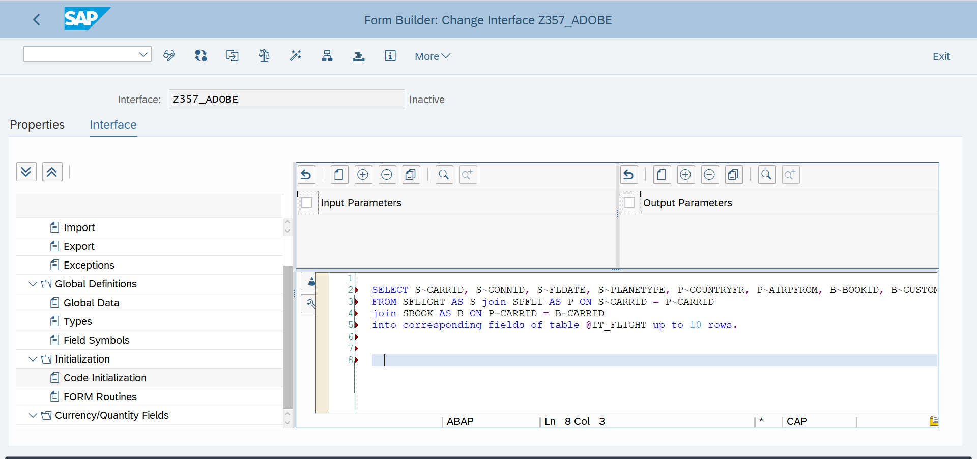

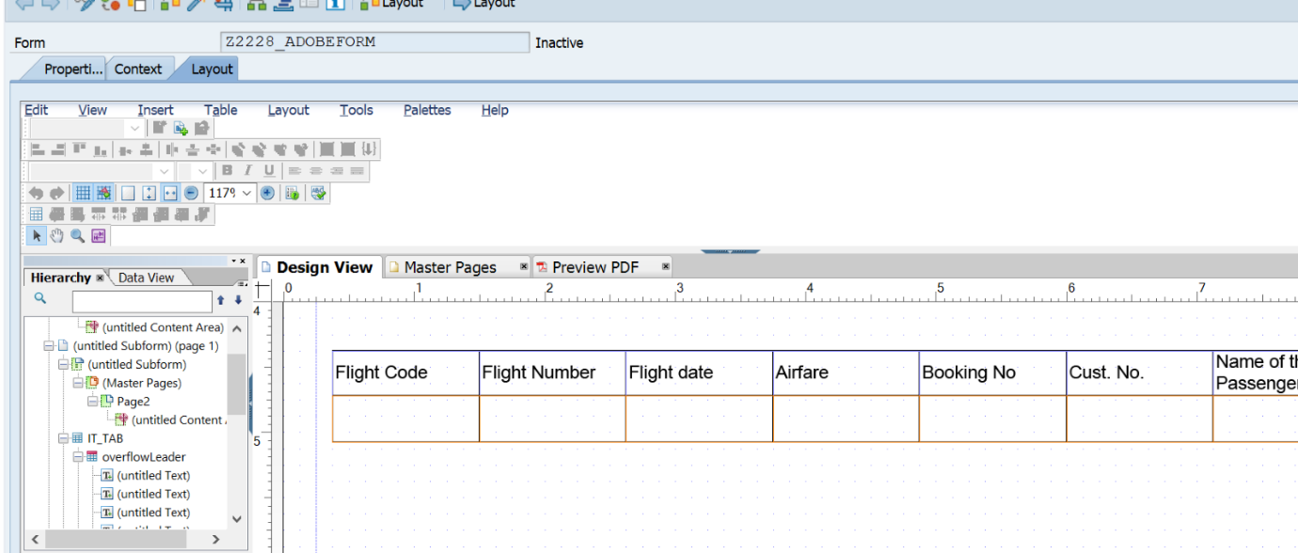

REPORT Z357_AF.    
    
tables : sflight ,spfli, sbook.    
    
data it_tab type standard table of Z357_AF

DATA  wa_oparams type sfpoutputparams.    
    
    
SELECT-OPTIONS : s_carrid FOR spfli-carrid.    
 SELECT spfli~carrid    
       spfli~connid    
       sflight~fldate    
       sflight~price    
       sbook~bookid    
       sbook~customid    
       sbook~passname    
FROM spfli INNER JOIN sflight    
ON spfli~carrid EQ sflight~carrid    
INNER JOIN sbook    
ON spfli~carrid EQ sbook~carrid    
UP TO 10 ROWS       *"selecting fields from SPFLI , SFLIGHT and SBOOK*    
INTO TABLE it_tab                                                    *"into internal table*    
WHERE spfli~carrid IN s_carrid.    
    
CALL FUNCTION 'FP_JOB_OPEN'    
  CHANGING    
    ie_outputparams       = wa_oparams            .    
IF sy-subrc <> 0.    
*\* Implement suitable error handling here*    
ENDIF.    
    
CALL FUNCTION '/1BCDWB/SM00001200'    
  EXPORTING    
*\*   /1BCDWB/DOCPARAMS        =*    
    it_tab                   = it_tab    
          .    
IF sy-subrc <> 0.    
*\* Implement suitable error handling here*    
ENDIF.    
    
    
CALL FUNCTION 'FP_JOB_CLOSE'    
*\* IMPORTING*    
*\*   E_RESULT             =*    
*\* EXCEPTIONS*    
*\*   USAGE_ERROR          = 1*    
*\*   SYSTEM_ERROR         = 2*    
*\*   INTERNAL_ERROR       = 3*    
*\*   OTHERS               = 4*    
          .    
IF sy-subrc <> 0.    
*\* Implement suitable error handling here*    
ENDIF.

**Output**:

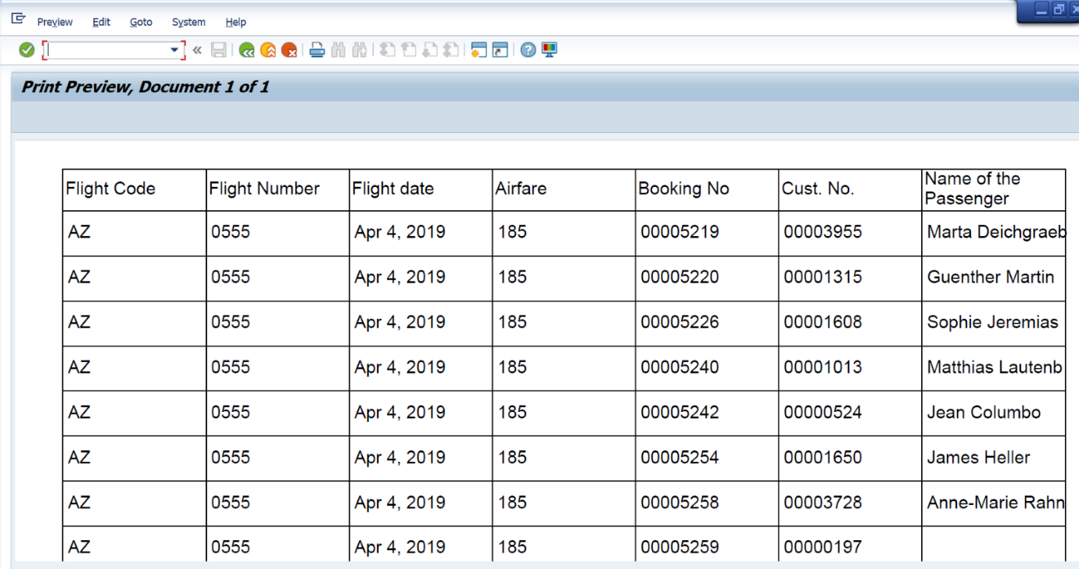

 Q2:  Java Script to display footer only last page .

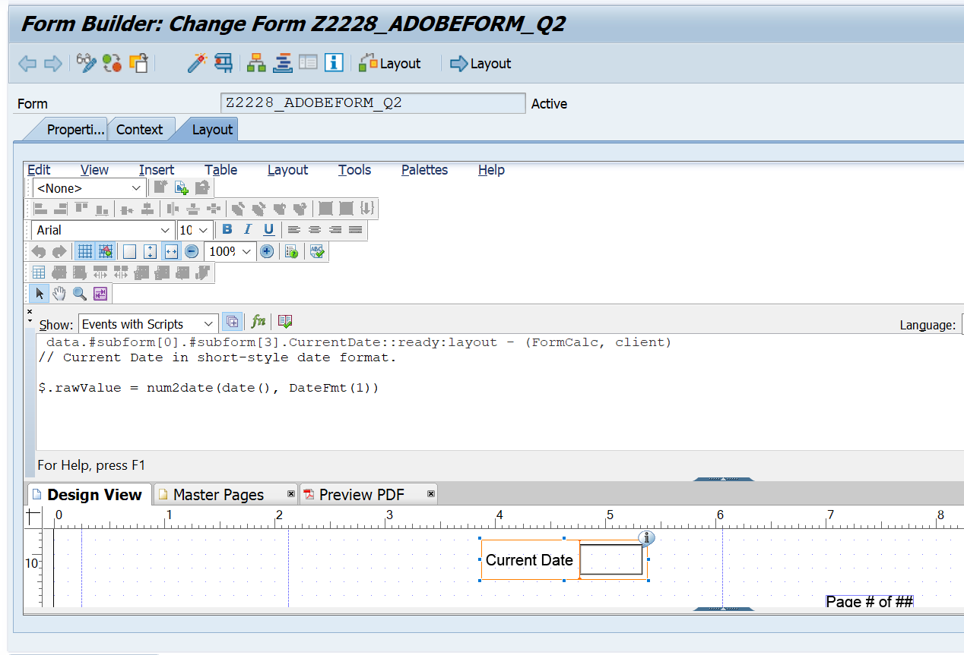

OUTPUT:



Q-4. Demonstrate a case to use Dynamic TEXT in adobe forms.

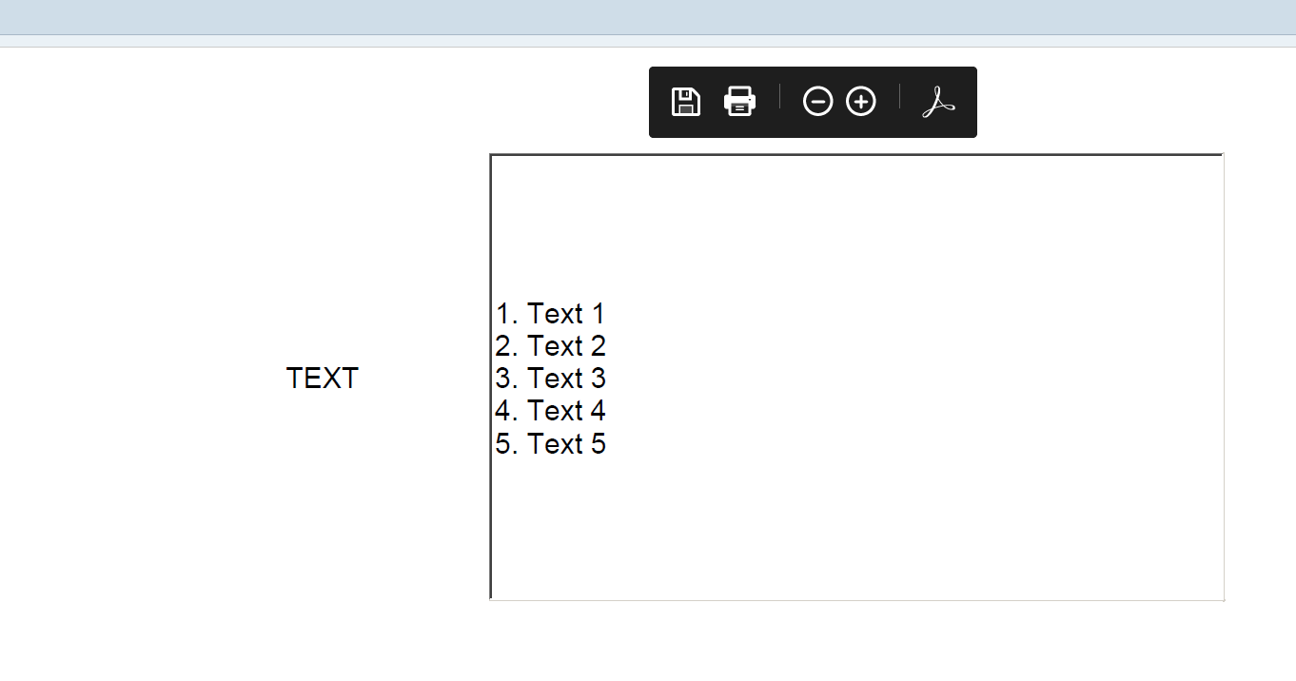

 Q-5. Demonstrate a case to use INCLUDE TEXT in adobe forms.

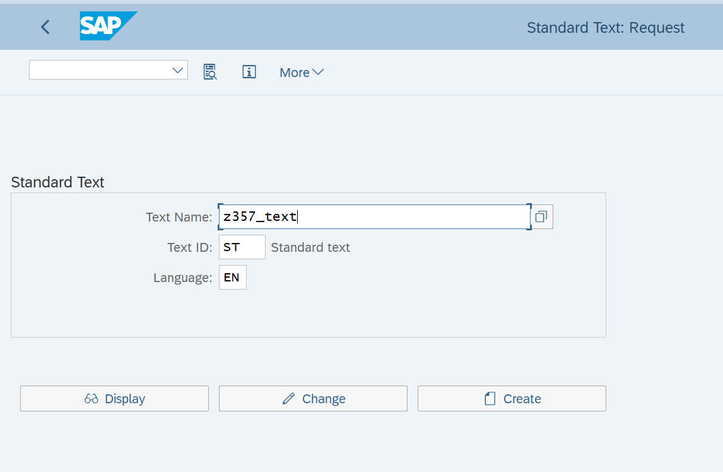

OUTPUT:

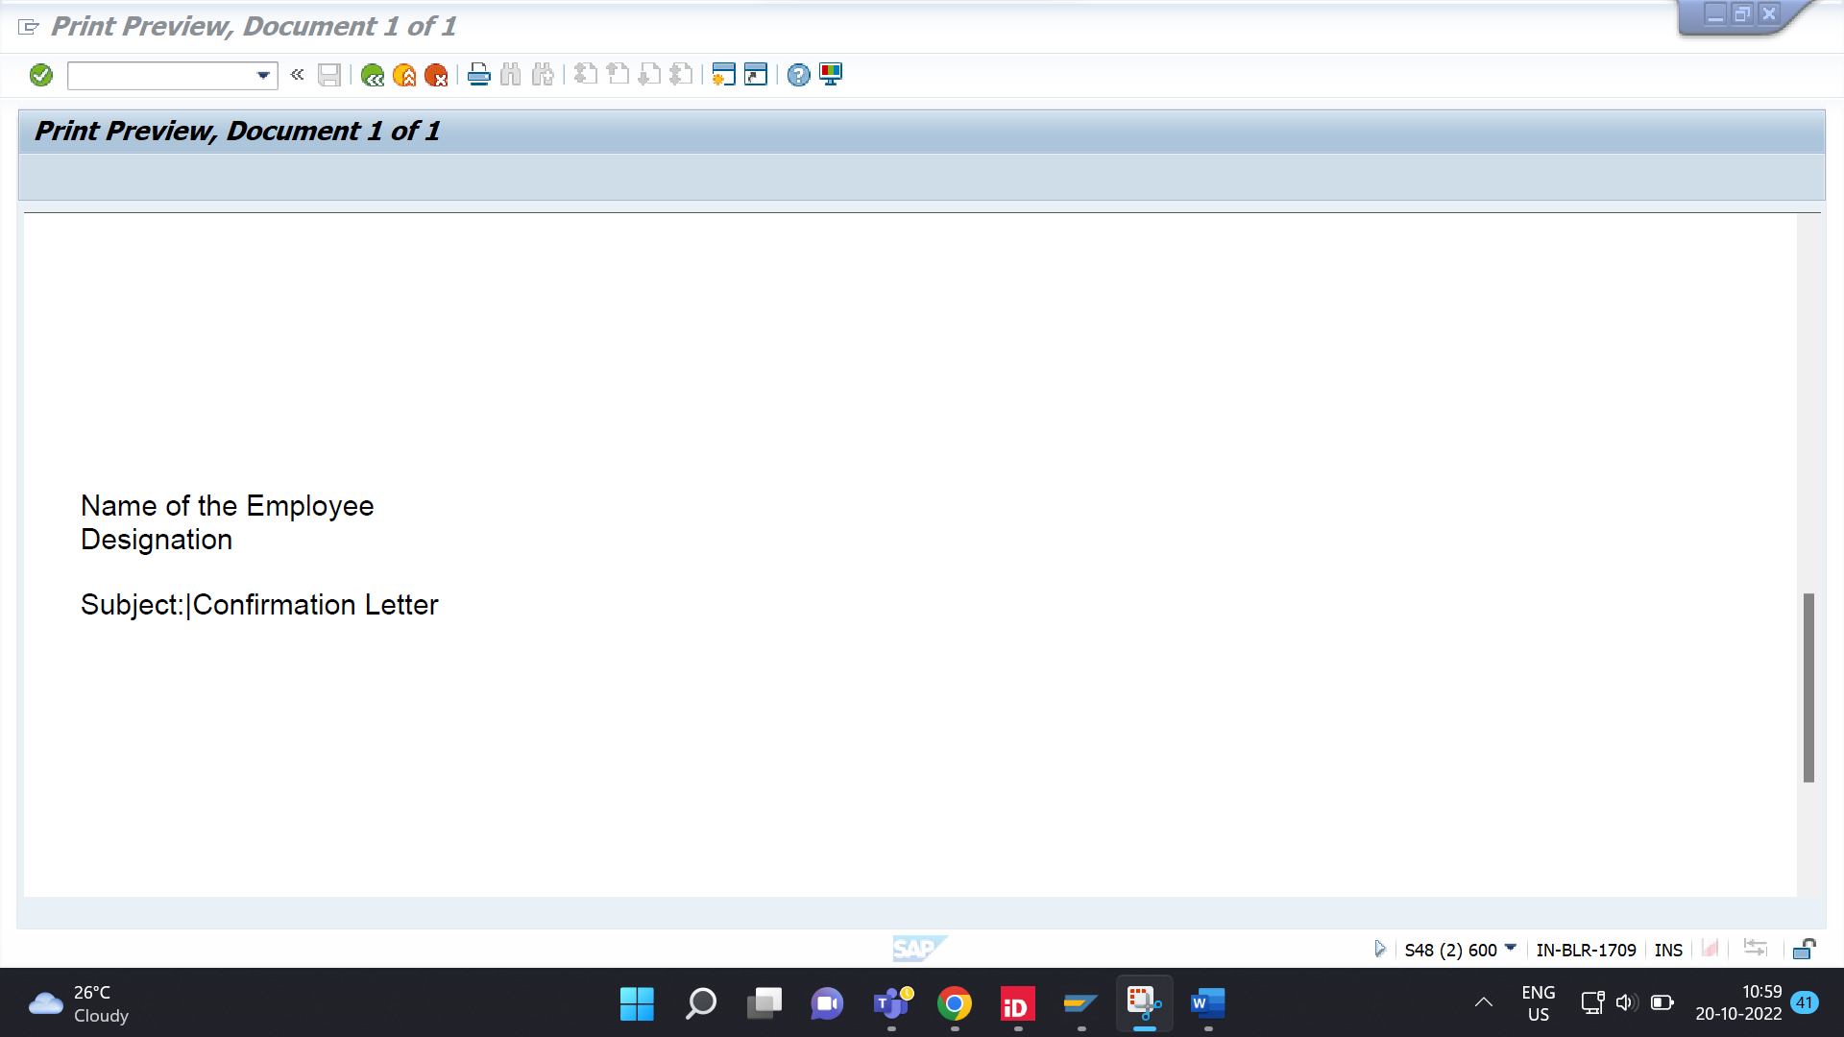

Q-6. Create a case to use image from SE78 in adobe forms.

